
Soft_Solutions4U
Quality System Procedure

Training Manual Template Effective from january 25.01.2011
January 25.01.2011



<< KMAIL Configuration on Ubuntu OS >>

Prepared By (SS4U) | Signature | R.MARIKKANNAN
Prepared By (SS4U) | Name | R.MARIKKANNAN
Reviewers | Signature
Reviewers | Name
Approves | Signature
Approves | Names

Soft_Solutions4U
Quality System Procedure

Training Manual Template Effective from January 25.01.2011
January 25.01.2011

KMAIL Configuration in Ubuntu OS

Step :1

Installation of KMAIL Client in Ubuntu OS

Installation of kmail in Ubuntu OS can be done in two ways

1.Synaptic package mananger /*GUI Mode*/

2.apt-get install /* Command Mode */

Installation through “Synaptic Package Manager” by using the following path

Go to “System ----->Administration-------->Synaptic Package Manager”

In that “Synaptic Package Manager” search box you search package name as “kmail”,it will show

Packages. Then you make “Mark for Installation”,it will automatically download the packages from

internet and slove the depentance itself and also install the packages.

In Command mode,you execute the following command to install the kmail package.

#sudo apt-get install kmail*;

It will automatically download the package from internet and install it.

Soft_Solutions4U
Quality System Procedure

Training Manual Template Effective from January 25.01.2011
January 25.01.2011

Step :2

Configuration of Kmail for Gmail Account

After installation of Kmail, you access the kamil by using the following path.

Applications ------> Internet ---------> Kmail

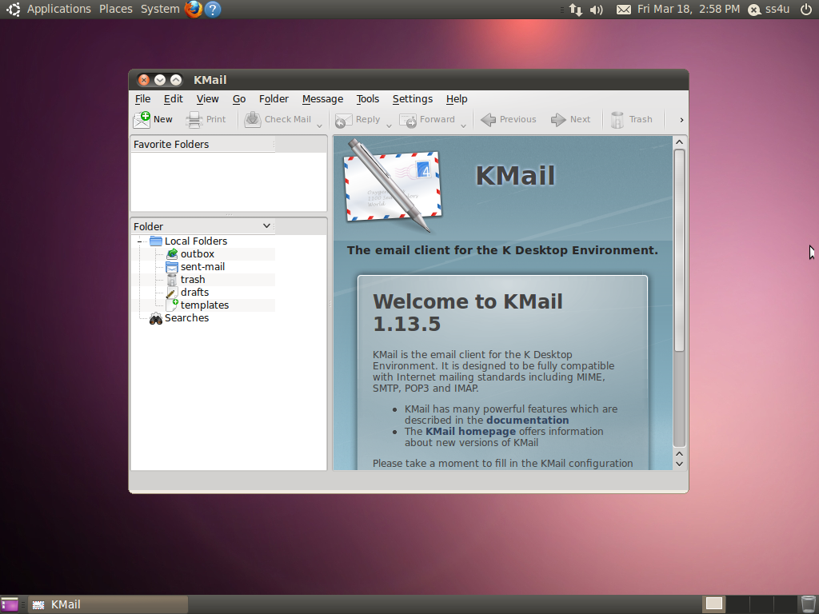

Soft_Solutions4U
Quality System Procedure

Training Manual Template Effective from January 25.01.2011
January 25.01.2011

In Kmail window, go to “Settings ------> Configure Kmail” then the following window will appear.

Here first you add the account by using “Add” button, in “Receiving part”, you choose “POP3”.

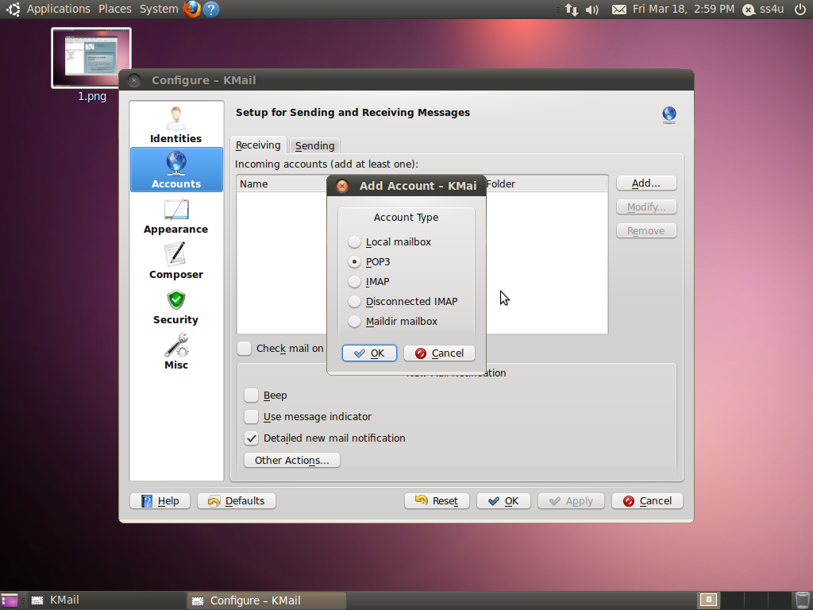

Here you click “OK” button for configure the POP3 mail client to access gmail account.

Soft_Solutions4U
Quality System Procedure

Training Manual Template Effective from January 25.01.2011
January 25.01.2011

The following screen will appear to configure the pop3 mail client, in “General” tab only.

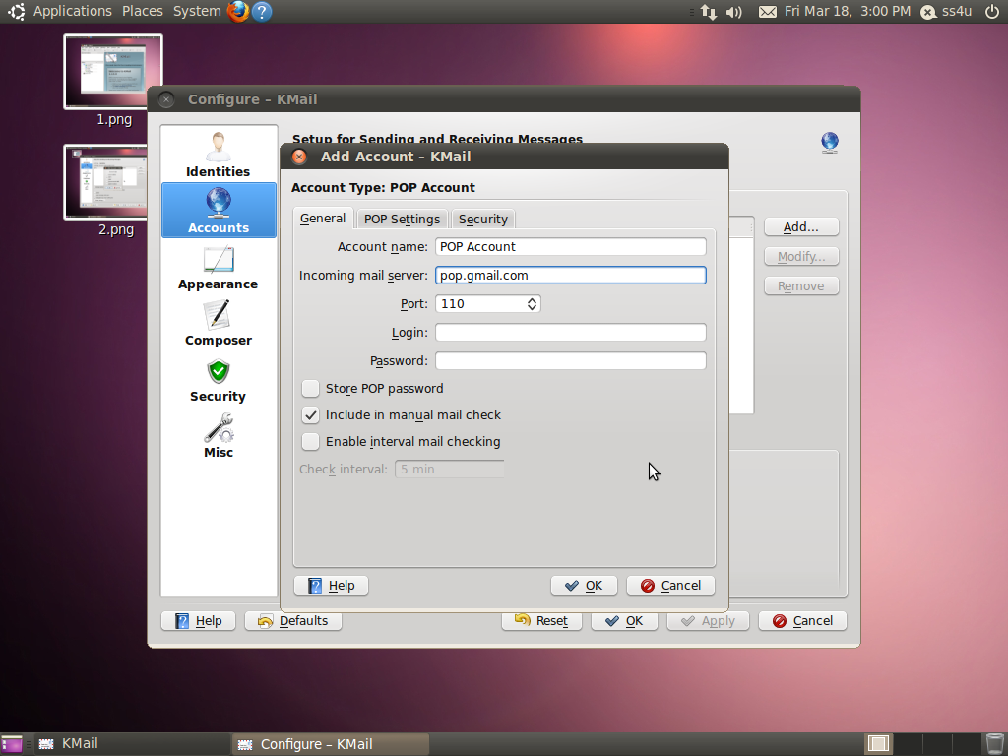

Set incoming mail server as “pop.gmail.com” and also set port number also.

It will ask Login name and Password.

Soft_Solutions4U
Quality System Procedure

Training Manual Template Effective from January 25.01.2011
January 25.01.2011

In “security” tab you can make the following changes for secure gmail client.

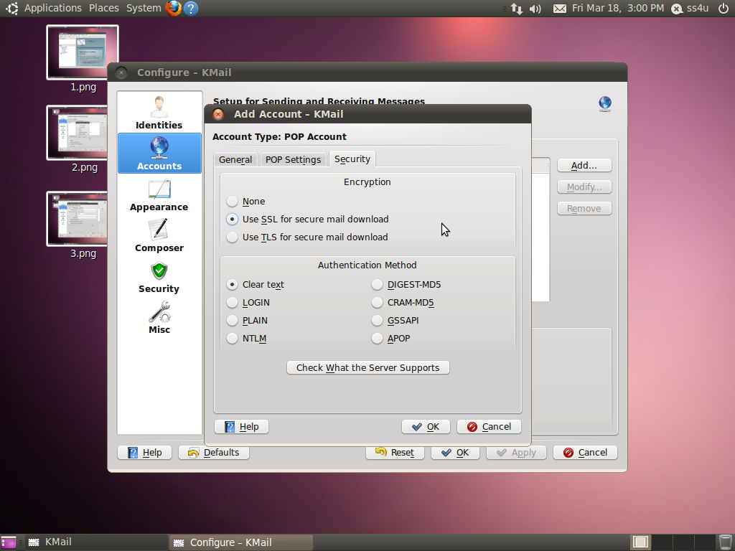

Set Encryption type as “Use SSL for secure mail download”.

And set Authentication type as “Clear text”.

Soft_Solutions4U
Quality System Procedure

Training Manual Template Effective from January 25.01.2011
January 25.01.2011

In “Sending part” you make the following changes to configure the outcoming mail.

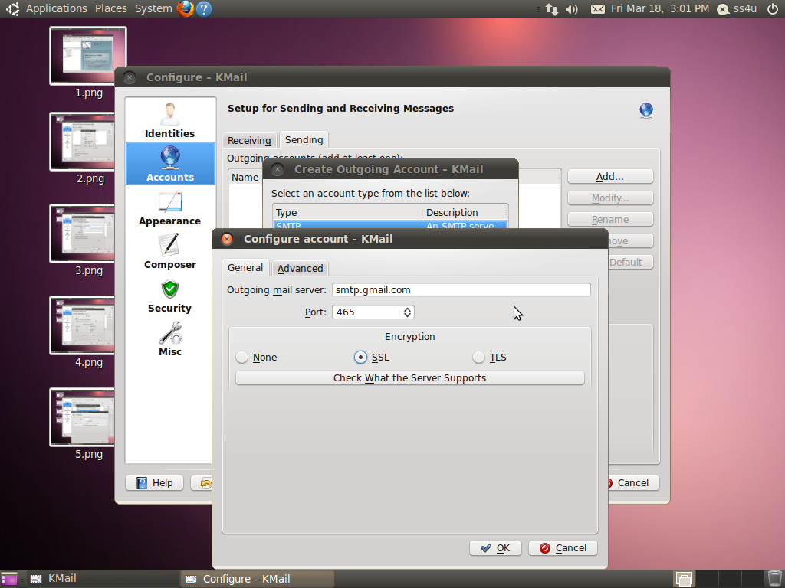

Here set outgoing mail server as “smtp.gmail.com”.

Set “Encryption” type as “SSL”.

Now you can access gmail account in kmail.

Soft_Solutions4U
Quality System Procedure

Training Manual Template Effective from January 25.01.2011
January 25.01.2011

Step :3

Importing Outlook Express File into Kmail

Importing files into kmail by using the following path “File ---->Import Messages”.

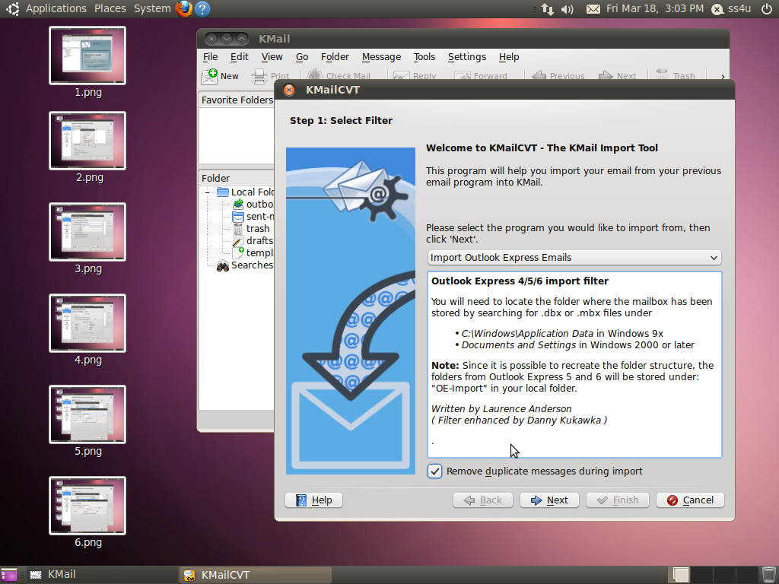
Here you choose import type as “Import Outlook Express Emails”. And also select the “Remove
duplicate messages during import”.

Soft_Solutions4U
Quality System Procedure

Training Manual Template Effective from January 25.01.2011
January 25.01.2011

The following window will appear,here you choose where you have the outlook express file.

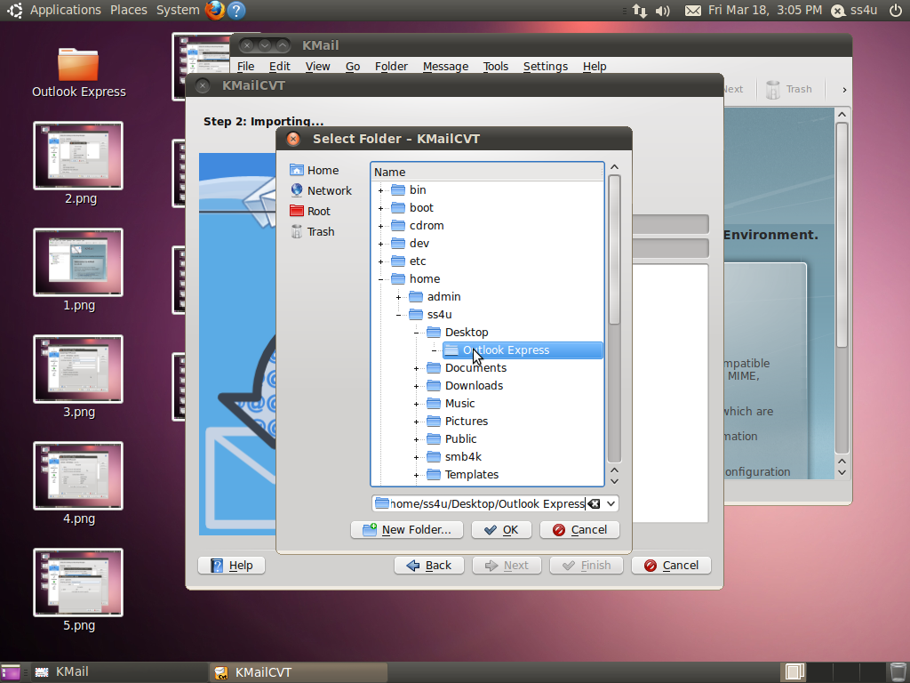

Here you give “OK” to import the “OutlookExpress File”.

Soft_Solutions4U
Quality System Procedure

Training Manual Template Effective from January 25.01.2011
January 25.01.2011

The following screen will show outlookExpress file importing to kmail

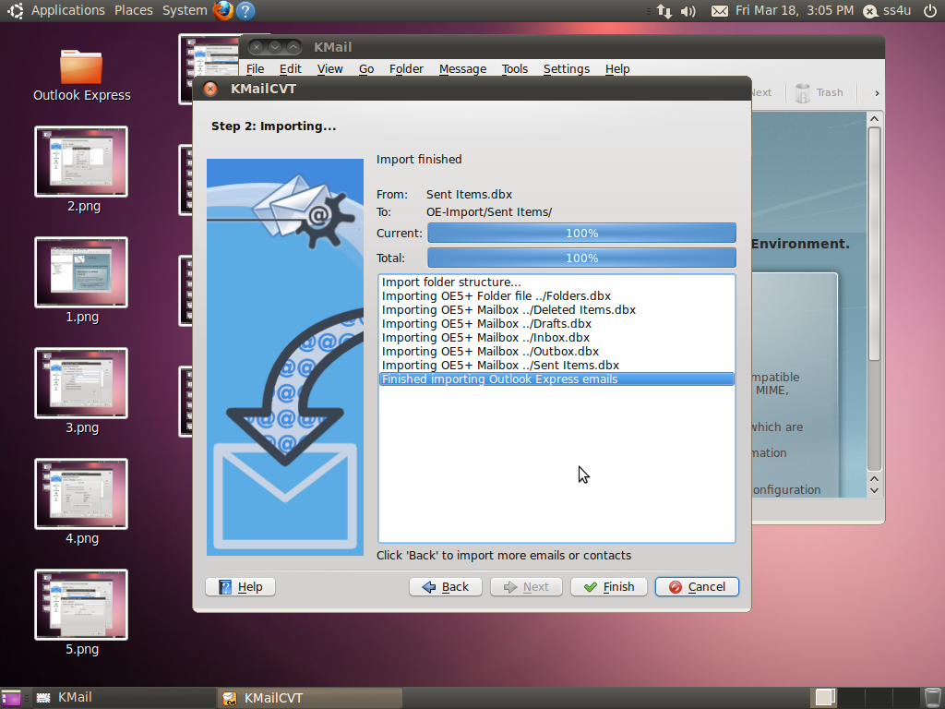

Here you select “Finish” button to proceed next step.

Soft_Solutions4U
Quality System Procedure

Training Manual Template Effective from January 25.01.2011
January 25.01.2011

Now you read the OutlookExpress file using Kmail Client.

